Guided Capstone Project Report

In the aim of our goal to come up with a pricing model for Big Mountain Resort (BMR), we trained a Random Forest Regression model on a dataset containing information for ~330 US-based resorts in BMR’s market share. Using this model, we predict that BMR’s currently offered facilities support a ticket price of $95.87, whereas the current price is $81.00. Even with the model’s expected mean absolute error (MAE) of $10.39, there seems to be room for a price increase. With ~1,750,000 expected ticket sales this season, this would provide an approximate $26,022,500 increase in revenue this year. This increase would certainly cover the additional $1,540,000 of operating costs incurred by the addition of the new chair lift. Prior to all this modelling, though, we checked to see how well the mean would perform as a predictor, and saw an MAE of ~$19.14.

To select which features of a ski resort most-strongly correlate with ticket price, we performed Principle Component Analysis (PCA) and produced a correlation heatmap for our data, providing a lot of component-relationship details at a glance and helping us to select the most important features for analysis (see Fig.1). PCA showed no clear state-based patterns in ticket price, as well. The result was the selection of ‘fastQuads’, ‘Runs’, ‘Snow Making_ac’, and ‘vertical_drop’ as our top four features.

Figure 1 - PCA Heatmap

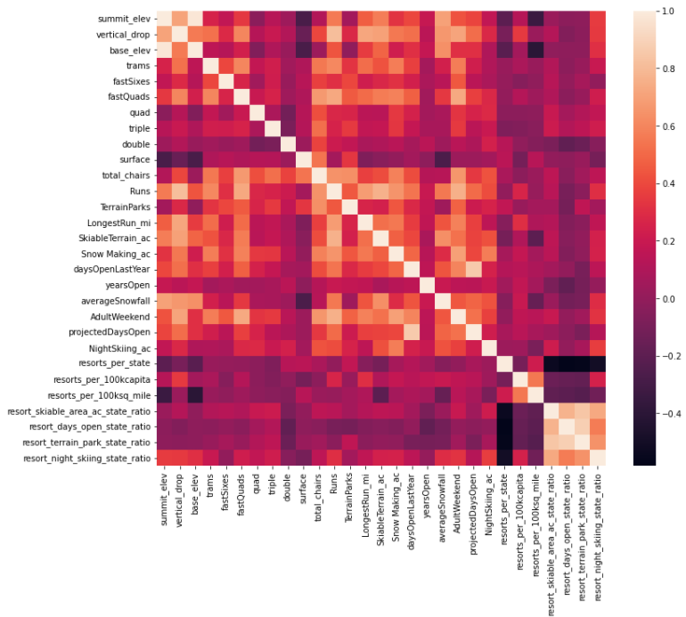

As for our selection of a Random Forest model, we trained and tested a simple Linear Regression model for comparison. After a performance evaluation via cross-validation, we decided to go with the Random Forest model as its MAE of ~9.54 proved a better fit than Linear Regression’s ~11.79. A quick data quantity assessment showed that we can be confident in our data quantity as well.

With our model trained and fit to the data, it can provide useful market analytics utilizing feature comparison across this population. For example, we can see where BMR lies in the ‘Adult weekend ticket price’ landscape, both nationally (see Fig. 2.1) and in Montana only (see Fig 2.2). BMR is certainly *the* premier resort in Montana, and one of the ‘heavy-hitters’ in the national market, as well.

**Figure 2.1** - BMR’s Ticket Price position nationally

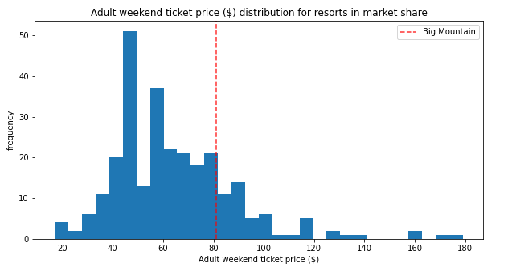

**Figure 2.2** - BMR’s Ticket Price position in Montana

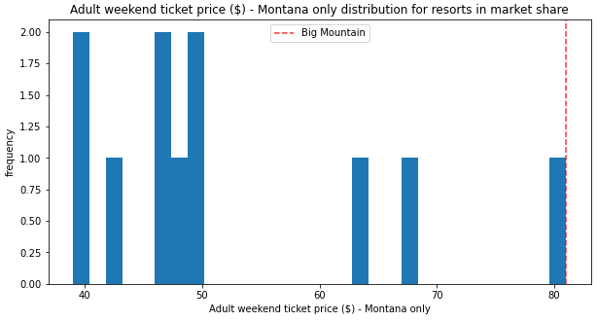

Finally, we can also apply our model to predict new supported ticket prices based on potential renovations or closures that BMR may consider in the future. In testing the proposed scenarios for BMR’s renovation, we predicted the most efficient option to be increasing vertical drop by 150 ft and adding another chair lift. This analysis showed an anticipated increase in supported ticket price by $8.61, which amounts to $15,065,471 over the season with our expected visitorship. As for potential run closures, the model predicts no ticket price impact with the closure of 1 run, but predicts a lower supported ticket price successively when 2 or 3 runs are closed. However, if 3 runs are closed, the resort may as well close down 4 or 5 runs. As the closures increase to 6 or more, a large drop in ticket price, and therefore seasonal revenue, is predicted.

These are all great predictors that can be implemented with confidence when considering our model’s expected MAE. However, there are a few features that, if included, could significantly increase the performance of this model. For example, if we were able to acquire data covering operating costs for the resorts in this list, we could hone in better on the strategy other resorts are using to optimize profits, and come up with a more-informed prediction for BMR’s ticket price.

Going forward, we recommend BMR consistently update this model with the most recent data available and use that to advise the ticket-pricing process. Further, business analysts may make use of this model, forecasting new supported ticket prices based on future changes.